**Methodology**

But what if we used an approach rooted in player performance? Identify players who played in more than one league within the same season or across consecutive seasons.

# # A tibble: 2,462 x 7

# Season Player `League A` `League B` `VAEP/90 A` `VAEP/90 B` Diff.

# <dbl> <chr> <chr> <chr> <dbl> <dbl> <dbl>

# 1 2020 Timo Werner Bundesliga 1 (Ge~ Premier League ~ 1.25 0.638 0.610

# 2 2020 Alexander Sø~ Super Lig (Turke~ Bundesliga 1 (G~ 1.07 0.773 0.296

# 3 2020 Hakim Ziyech Eredivisie (Neth~ Premier League ~ 0.958 0.365 0.593

# 4 2020 Nicolás Gonz~ Bundesliga 2 (Ge~ Bundesliga 1 (G~ 0.917 0.943 -0.0256

# 5 2020 Fabian Klos Bundesliga 2 (Ge~ Bundesliga 1 (G~ 0.904 0.547 0.358

# 6 2020 Victor Osimh~ Ligue 1 (France) Serie A (Italy) 0.889 1.01 -0.120

# 7 2020 Eldor Shomur~ Premier League (~ Serie A (Italy) 0.882 0.755 0.126

# 8 2020 Callum Robin~ Championship (En~ Premier League ~ 0.880 0.682 0.198

# 9 2020 Jarrod Bowen Championship (En~ Premier League ~ 0.871 0.448 0.423

# 10 2020 Aleksandar M~ Championship (En~ Premier League ~ 0.866 0.499 0.367

# # ... with 2,452 more rows

Why VAEP? Theoretically it should capture more about in-game actions (including defense) than other stats such as xG, which is biased in favor of attacking players. VAEP is not perfect by any means (e.g. it does not capture off-ball actions), but, in theory, it should be a better measure of overall performance.

Notably, we give up a little in interpretability in using VAEP, since it’s not directly translatable to goals. The following table of top season-long xG totals since 2012 to contextualize the magnitudes of xG and VAEP.

# # A tibble: 36,857 x 5

# Season Player Minutes xG VAEP

# <dbl> <chr> <dbl> <dbl> <dbl>

# 1 2015 Lionel Messi 3529 38.1 69.0

# 2 2016 Luis Suárez 3294 35.6 55.7

# 3 2018 Robert Lewandowski 2259 35.1 40.2

# 4 2012 Lionel Messi 3425 32.4 76.2

# 5 2013 Lionel Messi 2776 31.6 60.0

# 6 2015 Cristiano Ronaldo 3236 30.8 58.7

# 7 2018 Mohamed Salah 3080 30.4 50.5

# 8 2012 Cristiano Ronaldo 3504 30.1 62.7

# 9 2017 Edin Dzeko 3216 29.8 49.7

# 10 2020 Robert Lewandowski 2902 29.7 49.2

# # ... with 36,847 more rows

And a scatter plot, because who doesn’t love a graph.

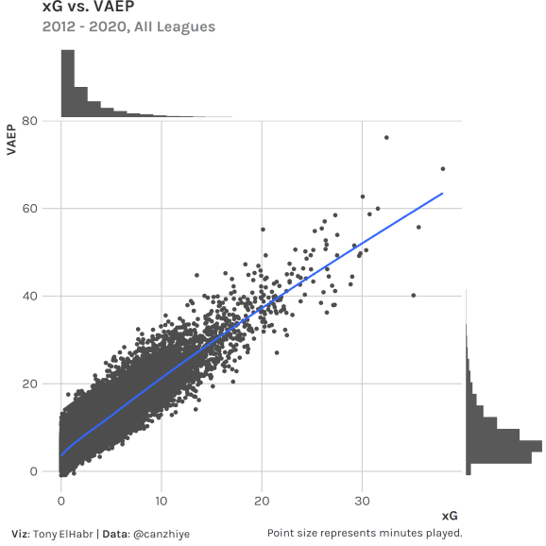

1. Convert the player-level VAEP/90 differences to z-scores by position and age group.

# # A tibble: 2,462 x 7

# Season Player Position `Age Group` `League A` `League B` `VAEP/90 Diff. Z`

# <dbl> <chr> <chr> <chr> <chr> <chr> <dbl>

# 1 2020 Timo Werner AM 24<=x<27 Bundesliga 1 (~ Premier Leagu~ 2.28

# 2 2020 Alexander ~ FW 24<=x<27 Super Lig (Tur~ Bundesliga 1 ~ 1.10

# 3 2020 Hakim Ziye~ M 27<=x<30 Eredivisie (Ne~ Premier Leagu~ 3.20

# 4 2020 Nicolás Go~ M 18<=x<24 Bundesliga 2 (~ Bundesliga 1 ~ -0.148

# 5 2020 Fabian Klos FW 30<=x<36 Bundesliga 2 (~ Bundesliga 1 ~ 1.20

# 6 2020 Victor Osi~ FW 18<=x<24 Ligue 1 (Franc~ Serie A (Ital~ -0.439

# 7 2020 Eldor Shom~ FW 24<=x<27 Premier League~ Serie A (Ital~ 0.471

# 8 2020 Callum Rob~ AM 24<=x<27 Championship (~ Premier Leagu~ 0.740

# 9 2020 Jarrod Bow~ AM 18<=x<24 Championship (~ Premier Leagu~ 1.89

# 10 2020 Aleksandar~ FW 24<=x<27 Championship (~ Premier Leagu~ 1.37

# # ... with 2,452 more rows

Why grouping? This is intended to account for the fact that attacking players and “peaking” players (usually age 24-30) tend to have higher VAEP/90, so their league-to-league differences have larger variation. The choice to normalize is perhaps more questionable. The mean of differences is ~0 for all groups already, but the dispersion is smaller without normalization (i.e. standard deviations are closer to 0). So, in this case, normalization should help the linear model capture variation.

# # A tibble: 20 x 5

# Position Age Group N Mean SD

# <chr> <chr> <int> <dbl> <dbl>

# 1 AM 18<=x<24 138 0 0.224

# 2 AM 24<=x<27 128 0 0.268

# 3 AM 27<=x<30 118 0 0.248

# 4 AM 30<=x<36 68 0 0.248

# 5 D 18<=x<24 203 0 0.112

# 6 D 24<=x<27 268 0 0.101

# 7 D 27<=x<30 295 0 0.0930

# 8 D 30<=x<36 316 0 0.0939

# 9 DM 18<=x<24 30 0 0.102

# 10 DM 24<=x<27 48 0 0.0913

# 11 DM 27<=x<30 20 0 0.105

# 12 DM 30<=x<36 13 0 0.0719

# 13 FW 18<=x<24 26 0 0.274

# 14 FW 24<=x<27 67 0 0.268

# 15 FW 27<=x<30 50 0 0.263

# 16 FW 30<=x<36 66 0 0.297

# 17 M 18<=x<24 113 0 0.173

# 18 M 24<=x<27 130 0 0.147

# 19 M 27<=x<30 189 0 0.185

# 20 M 30<=x<36 186 0 0.171

1. Run a single regression where the response variable is the z-transformed VAEP/90 difference, and the features are indicators for leagues leagues, where -1 indicates player departure, a +1 indicates player arrival, and all other values are 0.

For those familiar with basketball and hockey, this is similar to the set-up for an adjusted plus-minus (APM) calculation. Here, each feature column is a league (instead of a player), each row represents a player (instead of a “stint”), and the response is transformed VAEP/90 (instead of net points per possession).

# tibble [2,472 x 16] (S3: tbl_df/tbl/data.frame)

# $ VAEP/90 Diff Z-Trans : num [1:2472] -0.0825 0.3285 -0.0143 0.1137 0.1526 ...

# $ Serie A (Italy) : int [1:2472] -1 -1 -1 -1 -1 -1 -1 -1 -1 -1 ...

# $ Bundesliga 1 (Germany) : int [1:2472] 1 1 0 0 0 0 0 0 0 0 ...

# $ La Liga (Spain) : int [1:2472] 0 0 0 0 0 0 0 0 0 0 ...

# $ Serie A (Brazil) : int [1:2472] 0 0 0 0 0 1 0 0 0 0 ...

# $ Super Lig (Turkey) : int [1:2472] 0 0 1 0 0 0 0 1 0 0 ...

# $ Premier League (England) : int [1:2472] 0 0 0 0 0 0 0 0 0 0 ...

# $ Super League (China) : int [1:2472] 0 0 0 0 0 0 0 0 0 1 ...

# $ Major League Soccer (USA): int [1:2472] 0 0 0 0 1 0 1 0 0 0 ...

# $ Primeira Liga (Portugal) : int [1:2472] 0 0 0 0 0 0 0 0 0 0 ...

# $ Ligue 1 (France) : int [1:2472] 0 0 0 1 0 0 0 0 0 0 ...

# $ Bundesliga 2 (Germany) : int [1:2472] 0 0 0 0 0 0 0 0 0 0 ...

# $ Championship (England) : int [1:2472] 0 0 0 0 0 0 0 0 0 0 ...

# $ Premier League (Russia) : int [1:2472] 0 0 0 0 0 0 0 0 0 0 ...

# $ Superliga (Argentina) : int [1:2472] 0 0 0 0 0 0 0 0 1 0 ...

# $ Eredivisie (Netherlands) : int [1:2472] 0 0 0 0 0 0 0 0 0 0 ...

The result is a set of coefficient estimates corresponding to each league. Notably, these are all positive (even if subtracting the intercept), and the Netherlands coefficient is NA due to multi-collinearity in the data.

# # A tibble: 16 x 2

# League Estimate

# <chr> <dbl>

# 1 Premier League (England) 0.975

# 2 La Liga (Spain) 0.869

# 3 Ligue 1 (France) 0.786

# 4 Serie A (Italy) 0.738

# 5 Serie A (Brazil) 0.724

# 6 Primeira Liga (Portugal) 0.675

# 7 Bundesliga 1 (Germany) 0.649

# 8 Championship (England) 0.641

# 9 Super Lig (Turkey) 0.617

# 10 Premier League (Russia) 0.485

# 11 Superliga (Argentina) 0.463

# 12 Super League (China) 0.360

# 13 Major League Soccer (USA) 0.281

# 14 Bundesliga 2 (Germany) 0.197

# 15 (Intercept) 0.0747

# 16 Eredivisie (Netherlands) NA

For hockey/basketball APM, we would say the coefficient estimate represents how much a player contributes relative to an “average” player. We might be tempted to try to interpret these coefficients directly as well. Yes, we can infer the league “power rankings” from just this singular coefficient list (Premier League as the strongest and Bundesliga 2 as the weakest), but there are some issues.

* We first need to “un-transform” this back to the VAEP/90 scale. (See next step.)
* Note that this is not a zero-sum situation (even after un-transforming). There is no notion of a matchup between one league and another like there is in hockey/basketball with players on the ice/court. Instead, our data is more analogous to a player playing against themselves (not a set of players versus another set of players).
* Even if this were a zero-sum type of problem and the model returned some negative coefficient estimates, it’s unclear what the intercept (or 0) even means. Does it mean “average”? If so, what is an “average” league?
* We accounted for minutes played—the “per 90” denominator—prior to subtracting rates (difference in VAEP/90), which is different than how APM works. In APM, the minutes played is directly accounted for in the response variable (net points, divided by possessions).

The take-away here is that we can only interpret the model coefficients on a relative basis.

# # A tibble: 256 x 5

# `League A` `League B` `Estimate A` `Estimate B` Diff.

# <fct> <fct> <dbl> <dbl> <dbl>

# 1 Premier League (England) Premier League (England) 0.975 0.975 0

# 2 Premier League (England) La Liga (Spain) 0.975 0.869 0.107

# 3 Premier League (England) Ligue 1 (France) 0.975 0.786 0.189

# 4 Premier League (England) Serie A (Italy) 0.975 0.738 0.238

# 5 Premier League (England) Serie A (Brazil) 0.975 0.724 0.252

# 6 Premier League (England) Primeira Liga (Portugal) 0.975 0.675 0.300

# 7 Premier League (England) Bundesliga 1 (Germany) 0.975 0.649 0.326

# 8 Premier League (England) Championship (England) 0.975 0.641 0.334

# 9 Premier League (England) Super Lig (Turkey) 0.975 0.617 0.358

# 10 Premier League (England) Premier League (Russia) 0.975 0.485 0.491

# # ... with 246 more rows

1. “Un-transform” the coefficients of the regression using a “weighted-average” standard deviation and mean from the z-transformations of groups.

Interpretation after this transformation can be a little tricky. The differences between a specified pair of these post-transformed coefficients represents the expected change in an “average” player’s VAEP/90 (Diff. (VAEP/90)) when moving between the specified leagues.

# # A tibble: 256 x 4

# `League A` `League B` Diff. `Diff. (VAEP/90)`

# <fct> <fct> <dbl> <dbl>

# 1 Premier League (England) Premier League (England) 0 0

# 2 Premier League (England) La Liga (Spain) 0.107 0.0166

# 3 Premier League (England) Ligue 1 (France) 0.189 0.0295

# 4 Premier League (England) Serie A (Italy) 0.238 0.0371

# 5 Premier League (England) Serie A (Brazil) 0.252 0.0393

# 6 Premier League (England) Primeira Liga (Portugal) 0.300 0.0469

# 7 Premier League (England) Bundesliga 1 (Germany) 0.326 0.0509

# 8 Premier League (England) Championship (England) 0.334 0.0521

# 9 Premier League (England) Super Lig (Turkey) 0.358 0.0559

# 10 Premier League (England) Premier League (Russia) 0.491 0.0766

# # ... with 246 more rows

To interpret these differences as a percentage (so that we can “scale” the properly for a player with a VAEP/90 of 1.5, compared to a player with a lower VAEP/90 rate), we use the median VAEP/90 across all leagues as a “baseline”. For example, for Bundesliga -> Premier League, since the overall median VAEP/90 is 0.305 and the Diff. (VAEP/90) between league A and league B is 0.0509, the % Difference is 0.0509/0.305 = 17%.

# # A tibble: 256 x 5

# `League A` `League B` Diff. `Diff. (VAEP/90)` `% Diff.`

# <fct> <fct> <dbl> <dbl> <chr>

# 1 Premier League (England) Premier League (England) 0 0 0%

# 2 Premier League (England) La Liga (Spain) 0.107 0.0166 5%

# 3 Premier League (England) Ligue 1 (France) 0.189 0.0295 10%

# 4 Premier League (England) Serie A (Italy) 0.238 0.0371 12%

# 5 Premier League (England) Serie A (Brazil) 0.252 0.0393 13%

# 6 Premier League (England) Primeira Liga (Portugal) 0.300 0.0469 15%

# 7 Premier League (England) Bundesliga 1 (Germany) 0.326 0.0509 17%

# 8 Premier League (England) Championship (England) 0.334 0.0521 17%

# 9 Premier League (England) Super Lig (Turkey) 0.358 0.0559 18%

# 10 Premier League (England) Premier League (Russia) 0.491 0.0766 25%

# # ... with 246 more rows

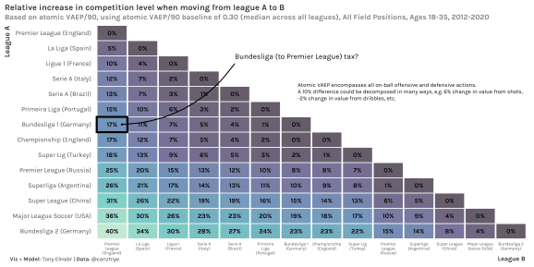

**Improvements & Further Work**

* Another weakness in my approach is the assumption that relative league strengths are the same every year, which is most certainly not true. One could apply a decaying weight to past seasons to account for varying league strength.
* I would be hesitant to use my results to directly infer how a specific player will translate going from one league to another. My approach focuses on leagues and is more about the “average” player. One aught to include additional features about play style (e.g. touches, progressive passes, team role) if interested in predicting individual player performance with a high degree of accuracy. 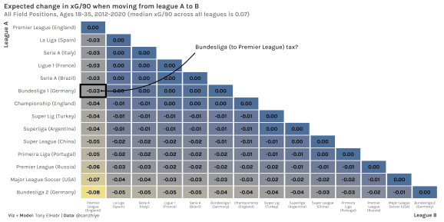
* One can swap out the response variable with other reasonable metrics of player performance, such as xG (which is more readily available than atomic VAEP). In fact, I did this myself and came up with the result below (showing in units of xG/90 instead of as a percentage, since most fans are accustomed to seeing xG and are used to it’s relative magnitude).
* One could stay in the realm of just purely “power rankings” and focus more on the estimates and error. For example, in an earlier iteration of this methodology, I used a Bradley-Terry approach to come up with a distribution of estimates for each league. Here, the x-axis could be loosely interpreted as the log odds of one league winning in a match versus another league, although it’s not clear exactly what that means. (An “average” team from both leagues? A matchup of teams composed of “average” players from any team in each league?)

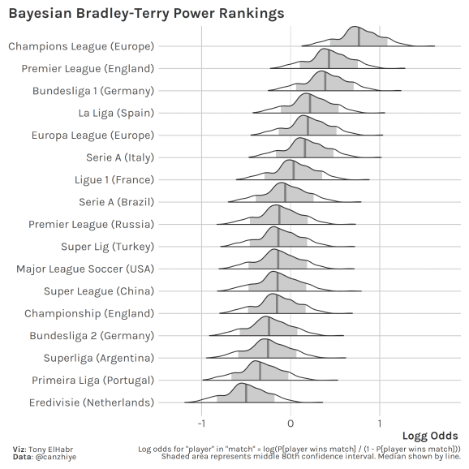

* Notably, I’m not using match results at all! Certainly a model could learn something from international and tournament matches. However, using match-level data would require a whole new approach. Also, most would agree that tournament data can be biased by atypical lineups. For example, a manager on one side may opt to rest their best players, saving them for domestic league games, while the other manager may play their side at full strength.
* Sample size is an issue on two levels: (1) the number of transfers (more data would be better) and (2) minutes played.

Regarding (1), one could expand the data set by including all seasons played by a player that has played in more than one league, taking all combinations of seasons in different leagues (i.e. relaxing the the same-season or subsequent-season criteria). I actually did attempt this and found that overall the results were somewhat similar, but there were more questionable results overall. (Brazil’s Serie A was found to be the second strongest league overall with this approach.).

Regarding (2), one has to make a choice to drop players with low minutes played to prevent outliers affecting the results of the model. However, in some cases, a loaned player coming in at the end of the season and making a huge impact can tell us a lot about the difference in strength of two leagues, so we may not want to drop some of the records after all.

On the topic of “shrinking”, we could have used ridge regression (regression with some penalty) to get more robust league estimates overall. However, there is a downside to ridge regression—we give up some level of interpretability. Nonetheless, the relative ranking of leagues would be more reliable with ridge regression. 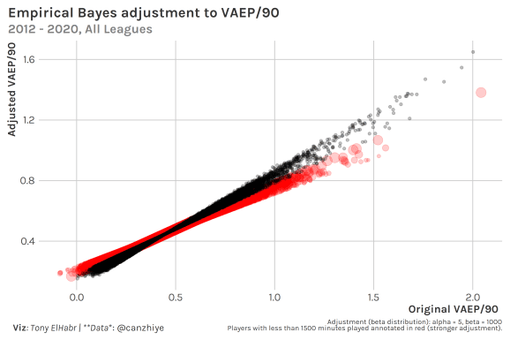

**Ancillary Take-away**

One final thing I’d like to point out here: I think this whole approach really showcases the inference made possible by player stats (xG, possession value metrics like atomic VAEP, etc.) aggregated over long periods of time. While such stats are often used to evaluate player performance in single games or even for singular in-game actions, they are most effective in providing insight when employed in higher-level analyses.